UNIFORM GUIDE
At TAG, our children wear their uniforms with pride!
You can click here to order your TAG school uniforms online from Cookie's.
At Cookies, the plaid number is 68. Orders over $25 ship for free, and 5% of all sales will be donated back to TAG, just remember to enter the coupon code TAGES or TAGMS at checkout.

Grades K-5 Daily Uniform

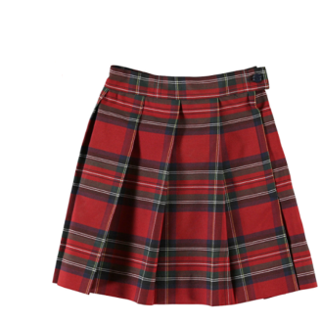
- Red plaid #68 jumper dress or skirt
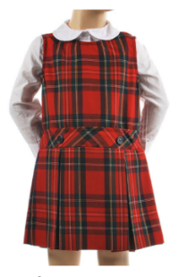

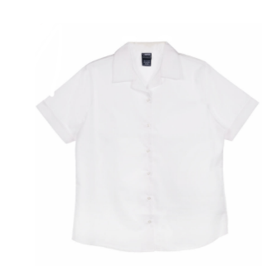
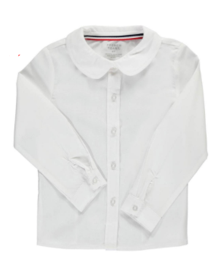
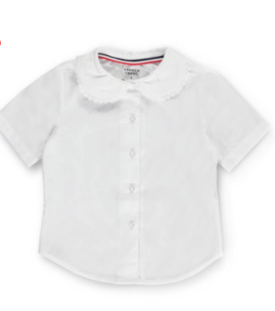
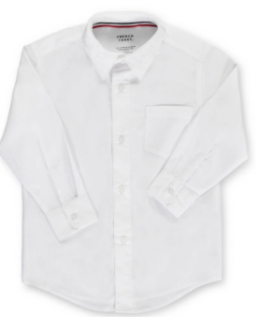
- White button-down shirt (long or short sleeve)

- Gray pants
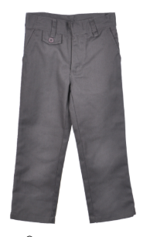

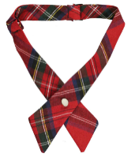
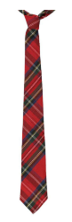
- Crisscross neck tie (pattern #68) or Tie (pattern #68)

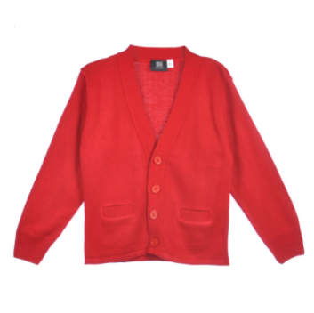
- Red cardigan or red pull-over sweater vest (in winter)
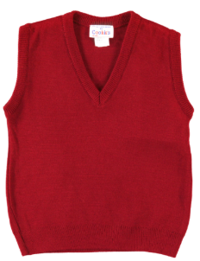

- Black or navy shoes
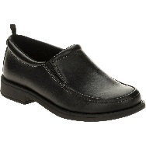
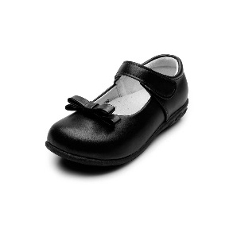

- Black or navy belt
- Socks or tights (white, black, navy)

Grades 6th-8th Uniform
- White button-down shirt (long or short sleeve)

- Navy pants, navy skirt or plaid #36 skirt
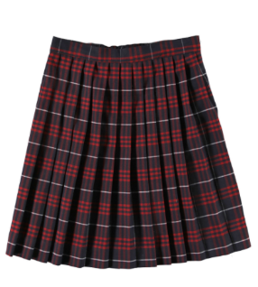
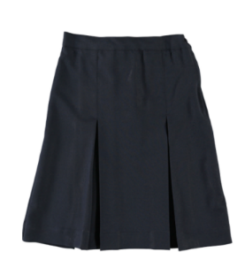
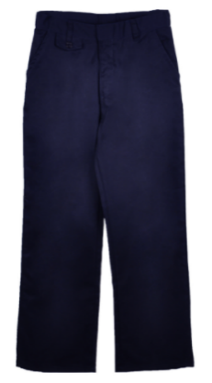

- Tie (navy) or Crisscross neck tie (navy)
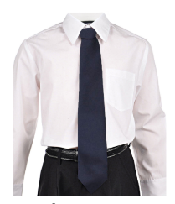
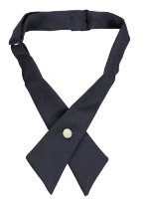

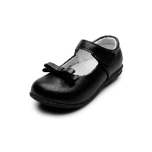
- Black or navy shoes

- Black or navy belt
- Socks or tights (white, black, navy)
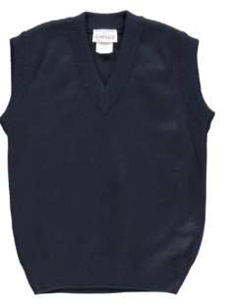
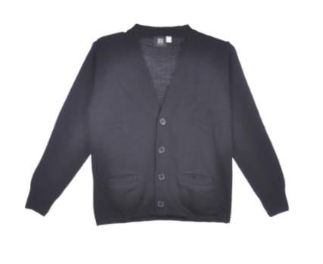
- Navy cardigan or navy pull over sweater vest (in winter)

Grades K-8 Gym Day Uniform
(worn all day on gym days)

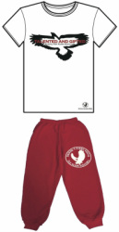

- TAGwear t-shirt or a plain white t-shirt
- TAGwear sweatpants or plain red sweatpants
- Sneakers

